
Lesson 9: On the Scoreboard
TIC-80
VIDEO GAME CREATION
This week: track a real score, and show it - along with your lives - on screen, all the time, not just at the end.
Open your own [YourName]Game project from Lesson 8 - don't start a new one.
Tip: no new assets this week - this is a logic and UI lesson.

Setup
- Launch TIC-80 and load your cart from Lesson 8.
- Press Esc to reach the code editor.

Level 1 - Minimal (MVP)
Destroying an enemy adds 10 points to your score. Score and lives are both visible on screen, all the time, not just at the start or end of the game.
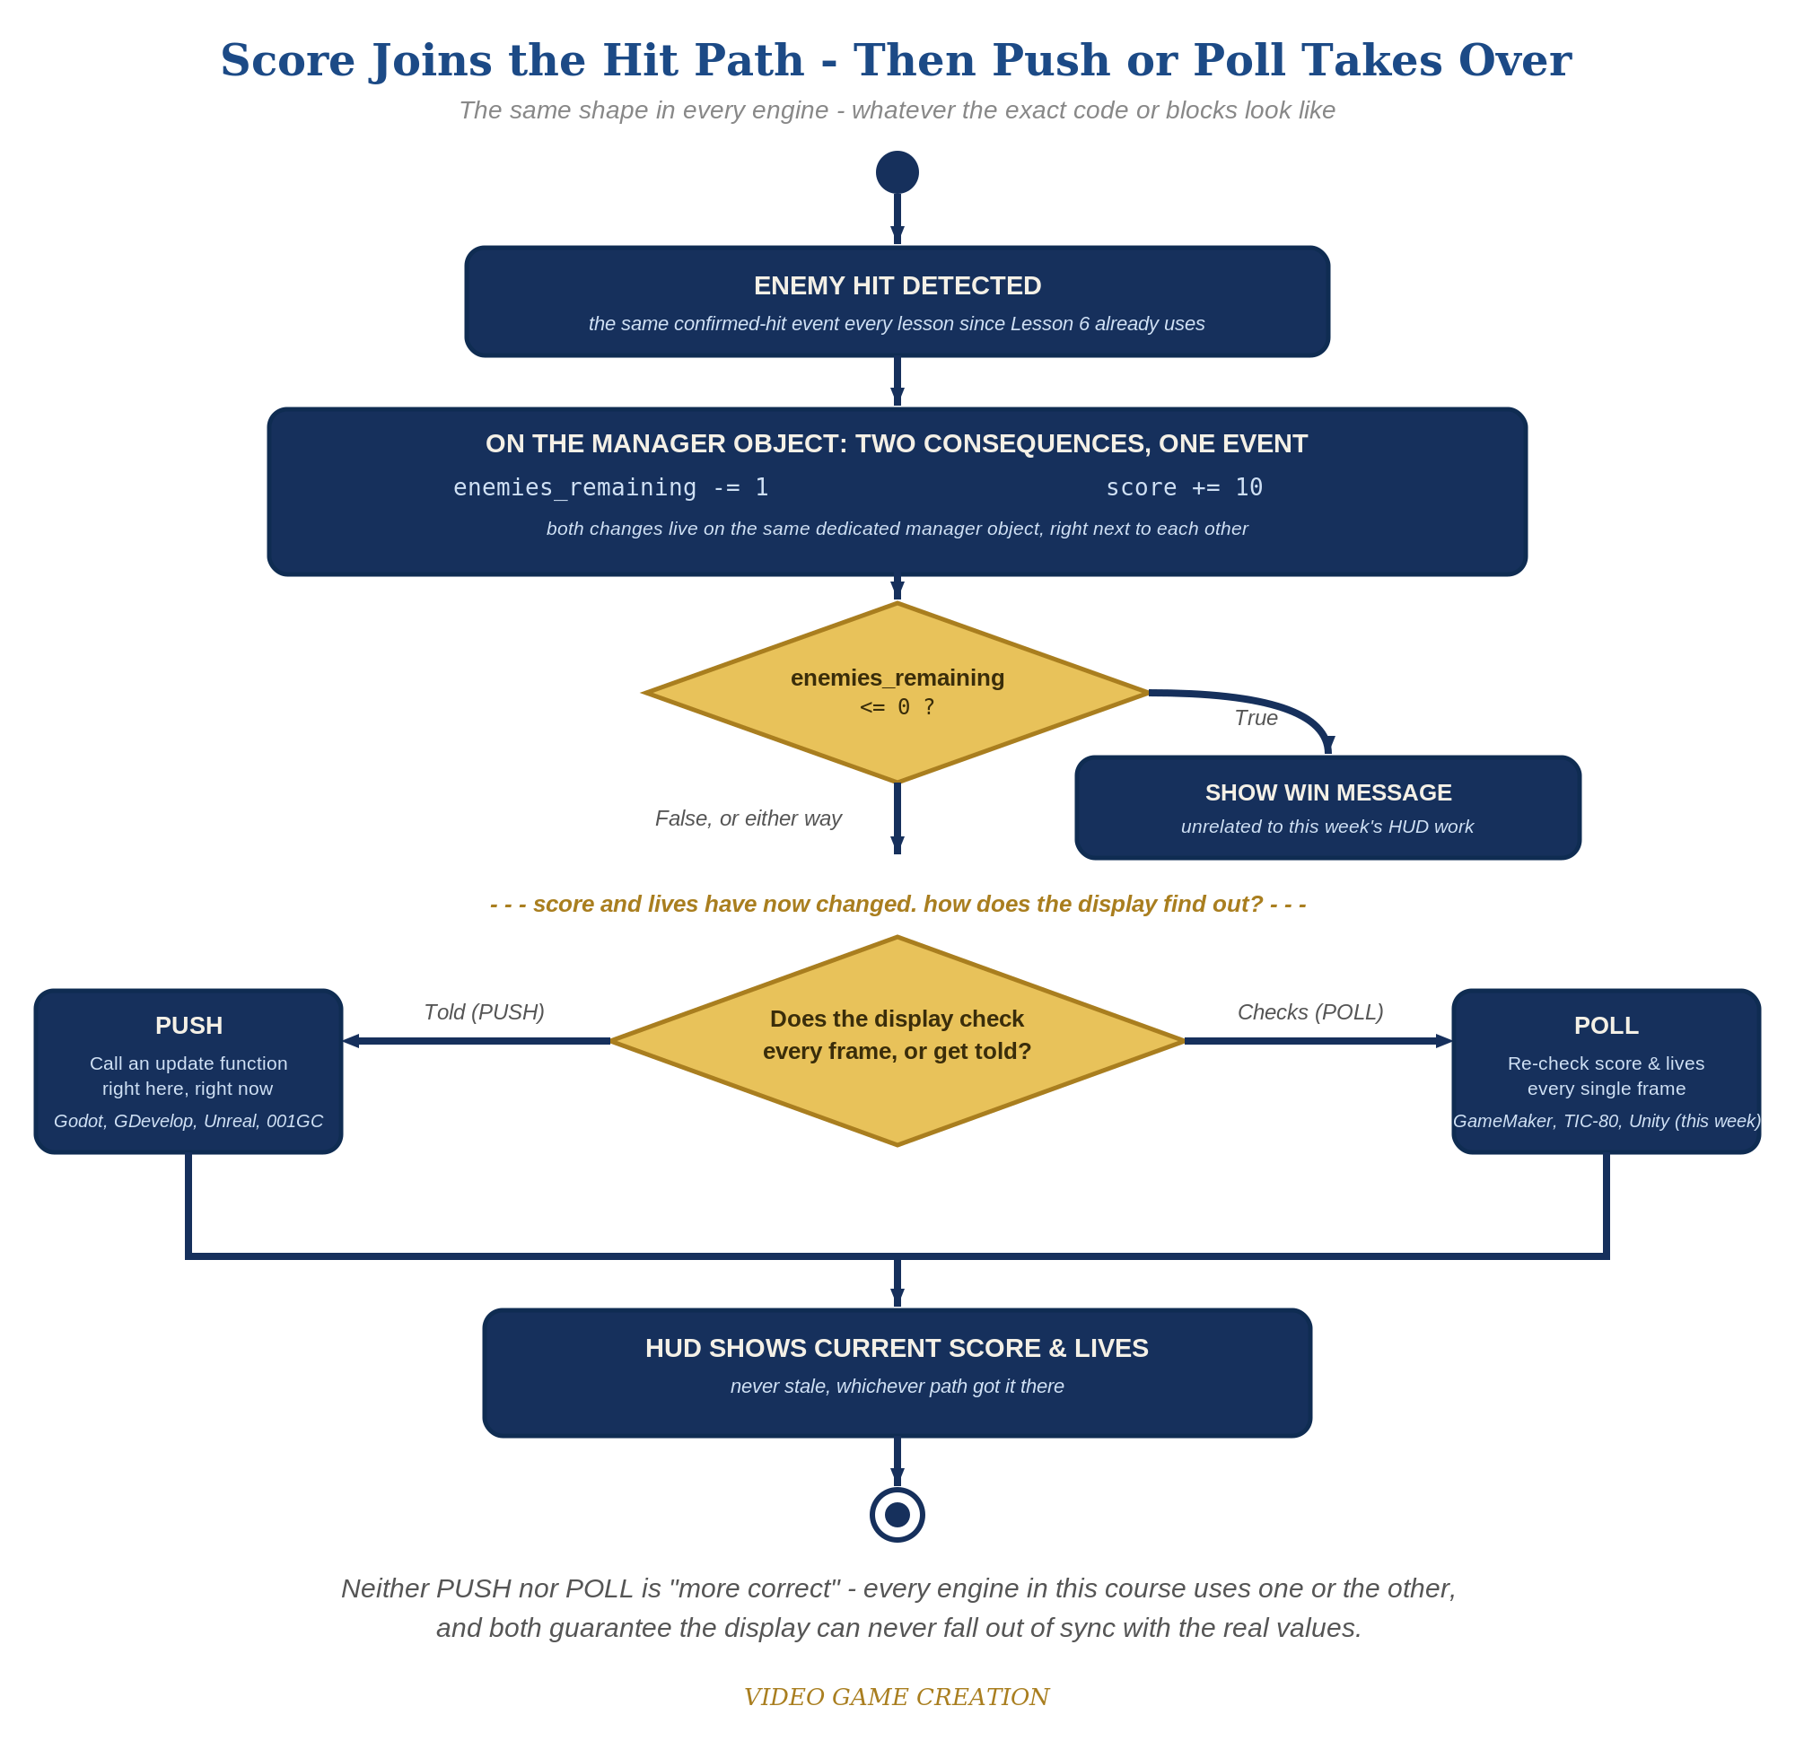
Score joins the hit path, then Push or Poll takes over - the same shape in every engine, whatever the exact code or blocks look like.
- Add score=0 near the top of your code, alongside lives and enemies_remaining.
- In the bullets loop's hit branch (where enemies_remaining decrements), add score=score+10.
- At the bottom of TIC(), add two unconditional print() calls - one for score, one for lives - so they display every single frame (code below).
- Press Esc, type run, press Enter, then shoot a few enemies and let one escape - both numbers should update immediately every time.
Highlighted lines are new this week; everything else is code you already have.
-- top of your code, alongside lives and enemies_remaining:
score=0
-- bullets loop's hit branch:
-- ...existing overlap check...
e.alive=false
enemies_remaining=enemies_remaining-1
score=score+10
-- bottom of TIC(), unconditional every frame:
print("Score: "..score,5,5,12)
print("Lives: "..lives,5,15,12)

Level 2 - Complete (Alpha/Beta)
The score and lives readouts never show a stale or wrong number - they always match reality, immediately.
- Shoot 3 enemies and confirm the display reads exactly "Score: 30".
- Let an enemy escape and confirm the score display does NOT change - only the lives display should move.
- Because these print() calls run every single frame with no caching, the display can never be out of sync with the real values.

Level 3 - Refined (Ready to Publish) - pick any that interest you
- Visual: change the color argument (the last number) in the print() calls, or reposition them, for a more game-like HUD look.
- Visual: change points-per-kill to math.random(5,15) for scoring variety.
- Structure: keep the score increment inside the bullets loop's hit branch - the same place enemies_remaining already changes, since both are direct consequences of the exact same confirmed hit.

If Something's Wrong
- Score doesn't appear: confirm the print() calls are actually inside TIC() (which runs every frame), not accidentally placed above it in the one-time setup code.
- Score changes when an enemy escapes: confirm score=score+10 is only in the bullets loop's hit branch, not the enemy-drawing loop's escape branch.
- Score and lives text overlap other text: adjust the Y coordinates in the print() calls so they don't collide with the You Win!/Game Over messages.

Want More?
Student Resource List > TIC-80 section, or tic80.com

